Power Focus

LINECARD

□ 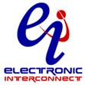

□ 

□ 

□ 













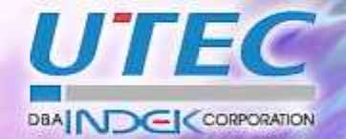

- 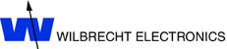

STSCO Mission:

As a professional Manufacturers Representative, our goal is to provide quality solutions from a portfolio of complementary manufacturers. Through first class technical support and quick response support on all aspects of procurement, we aim to maximize our customers’ success in their development and production efforts.

STSCO Method:

- Our manufacturers can provide board level and box level solutions for all aspects of electronic and electrical design.
- We support all channels for procurement including direct and through distribution.
- Samples and pricing are available through our office.
- Literature and technical support are also provided.

Product Types

ASICs:
TLSI

Capacitors:
Nichicon (Electrolytics, Double Layer, Solid Conductive Polymer, Tantalum, Film)
Union Technology Corp. (Multilayer Ceramic)

Connectors:
FCT Electronics (Mixed D-Subs, RF)
Interconnect Devices Inc. (IDI)
Sanhe (Terminal Blocks)

Fans:
UTEC

Isolation Devices:
Isolink

LED Assemblies:
WilbrechtLedco
Ligitek Electronics Co. Ltd.

Membrane Keypads:
CSI Keyboards

Packaging:
Sanhe

Printed Circuit Boards:
Electronic Interconnect (Hard Boards)

Protection Devices:
Protek Devices

Resistors:
Wilbrecht

Switches:
WilbrechtLedco

